**Earthquakes Analysis report** by Arvind Shiv Tej Reddy Gongati

1.

a) Sheet 1: Top 3 years with maximum magnitude earthquakes

b) Sheet 2: Box and whisker plot of the magnitude of earthquakes by years

Median of the magnitude of the earthquake:

* The median of the magnitude of earthquake data is **8.000**.

The maximum and minimum magnitudes of earthquake:

* The maximum magnitude of the earthquake was 9.600 in the year 1960, and the minimum magnitude of the earthquake was 6.900 in the year 2014.

2.

a) Sheet 3: Map Visualization measuring the maximum magnitude

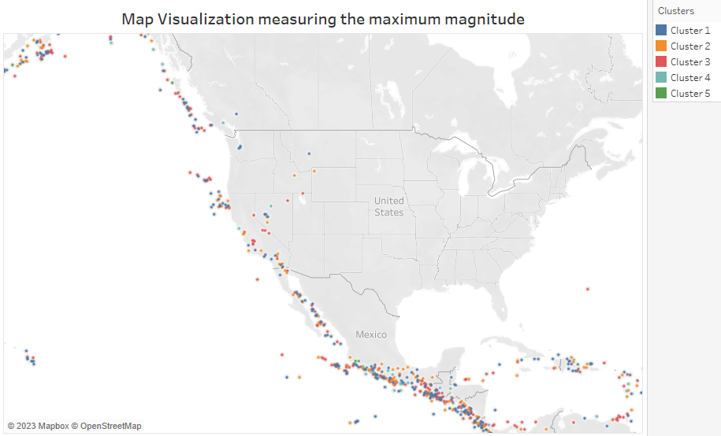

Which cluster has the maximum magnitude of earthquakes?

* **Cluster 1** has the maximum magnitude of earthquakes.

b) Sheet 4: Places where the Magnitude Type is ‘mwr’ or ‘mwp’:

5. Images of the dashboards:

Dashboard 1:

Dashboard 2:

Sheet 3: Visualization of my choice

Insight: The following visualization shows the top 10 counts of earthquakes that happened over the years. The counts are sorted in the decreasing order.

Sheet 4: Visualization of my choice

Insight: The following visualization represents the distribution of the type of magnitude over the years from 1900 to 2013.

SCREENSHOTS OF THE STORY:

1. Description: The following story point displays two visualizations. The first visualization shows the top 3 years, i.e., 1960, 1964, and 2004, had earthquakes with maximum magnitudes compared to others from 1900 to 2013. The second visualization shows the distribution of the magnitude of earthquakes over the years. The maximum, minimum, median, lower (25%), and upper percentile (75%) of the magnitude of earthquakes can be obtained from the box plot.

1. Description: The following visualizations represent the spread of the magnitudes. The Map visualization shows the cluster of magnitudes of earthquakes across the USA. The clustering is based on k-means clustering. Each cluster represents a specific class of magnitudes of earthquakes. On the other hand, the Gantt chart shows the quake's magnitude over different places across years.

1. Description: The following visualization shows the top 10 counts of earthquakes that happened over the years. The counts are sorted in the decreasing order. Therefore, 2011 had the highest number of quakes, with a count of 207. Also, most of the years among these earthquake counts are after 2000.

1. Description: The following visualization represents the distribution of the type of magnitude over the years from 1900 to 2013. The earthquakes of magnitude 6 are the highest, with a count of 1,178. From the visualization, it can be observed that most of the earthquakes' magnitudes are between 6 and 7.

